Block storage - Block storage provides persistent, low-latency block-level storage volumes that attach to EC2 instances like physical hard drives. Block storage volumes can be encrypted, backed up via snapshots, and modified while in use without disrupting the instance. AWS offers two primary block storage services:

* *Amazon EC2 instance store*  
  An unmanagednon-persistent, high-performance block storage directly attached to EC2 instances for temporary data.
* *Amazon Elastic Block Store (EBS)*  
  A managed service that provides persistent block storage volumes for EC2 instances, offering various types for different workloads.

*Benefits- 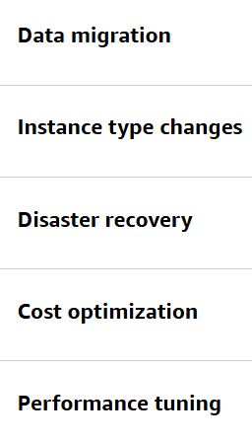*

EBS Snapshots - EBS snapshots are point-in-time backups of EBS volume. They can be used for disaster recovery, data migration, volume resizing, and for creating consistent backups of production workloads. EBS snapshots are incremental, so they only save the blocks on the volume that have changed after your most recent snapshot.

Amazon Data Lifecycle Manager -  automate the creation, retention, and deletion of EBS.

Object storage - Object storage is a data storage architecture that manages data as objects in a flat address space.

* *Amazon Simple Storage Service (S3)*  
  A fully managed scalable object storage service for storing and retrieving any amount of data from anywhere. Amazon S3 stores files as objects in containers known as buckets, and each object can range in size from a few bytes to several terabytes.

Each object typically includes the *data*itself, *metadata*, and a unique identifier, or *key*.

**Amazon S3 storage classes  -**

1. S3 Standard- general-purpose storage
2. S3 Intelligent-Tiering - unknown or changing access patterns
3. S3 Standard Infrequent Access (Standard-IA) - accessed less frequently but requires rapid access
4. S3 One Zone Infrequent Access (One Zone-IA) - stores data in a single Availability Zone
5. S3 Express One Zone - single Availability Zone , most frequently accessed data and latency-sensitive
6. S3 Glacier Instant Retrieval- rarely accessed and requires millisecond retrieval.
7. S3 Glacier Flexible Retrieval - when some data occasionally must be retrieved in minutes.
8. S3 Glacier Deep Archive - lowest-cost, It supports long-term retention and digital preservation for data that might be accessed once or twice per year.

S3 Lifecycle - configurations to automate the process.

* *Transition actions:* define when objects should transition to another storage class.
* *Expiration actions:* define when objects expire and should be permanently deleted.

File storage - AWS file storage services provide shared file systems accessible over networks, so multiple users and applications can access the same data simultaneously.

* *Amazon Elastic File System (EFS)*  
  A fully managed, scalable NFS ( It operates using the *Linux Network File System (NFS) protocol)* file system for use with AWS Cloud services and on-premises resources. It can be accessed by *multiple EC2 instances simultaneously*.

Benefits - 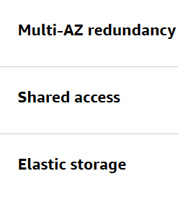

Amazon EFS storage classes - 

* *Amazon FSx*  
  A fully managed file storage services for popular file systems like Windows, Lustre, and NetApp ONTAP.

**Additional storage services –**

* *AWS Storage Gateway*  
  A fully managed, hybrid-cloud storage service that provides on-premises access to virtually unlimited cloud storage.

Gateway types –

1. *Amazon S3 File Gateway*
2. *Volume Gateway*
3. *Tape Gateway*

* *AWS Elastic Disaster Recovery*  
  A fully managed service that streamlines the recovery of your physical, virtual, and cloud-based servers into AWS.